
Session 3 Supporting Material
Use Cases, User Stories and Test Scenarios. Reference for Activities 1 to 3.
Fictional organisation and synthetic data: the organisation, its people and its figures are invented for teaching.
Use this during the activities. The worked examples use different content from the tasks, so you can copy the shape of each method but not the answer.

1. Writing a use case (Activity 1)
Field | What to write | Watch out for
Primary actor | The role that wants the goal, for example Tenant. | Several actors at once: pick the one whose goal it is.
Goal | What the actor wants, in their words, as a verb phrase. | A screen name ("the cancel page") instead of a goal.
Preconditions | What is already true before it starts. The steps do not check it. | Something the system must check: make it an extension.
Trigger | The event that starts the use case. | Leaving it out when a time or another system starts it.
Main flow | Numbered steps where nothing goes wrong (Cockburn calls this the main success scenario). Each step is an actor passing information, the system checking something or the system recording something. | System internals (tables, method names) and one giant step.
Alternative flows (extensions) | The step it branches from with a letter (2a), the condition the system can detect, what the system does, and how it ends. | A different goal (that is a separate use case), or a condition with no handling.
Postconditions | What is true when the goal succeeds, and what must still be true if it fails. | Results outside the use case, such as "the repair is fixed".

Worked example: Cancel a repair appointment (not the use case you write)
Field | Entry
Primary actor | Tenant
Goal | Cancel a booked visit and free the slot
Preconditions | The tenant is signed in; a visit is booked for the repair
Trigger | The tenant chooses Cancel on the visit
Main flow | 1. Tenant opens the repair and chooses Cancel.  2. System shows the date, time and trade.  3. Tenant gives a reason and confirms.  4. System cancels the slot with the scheduler.  5. System confirms by the tenant's chosen channel.
Alternative flows (extensions) | 2a. The operative is already on the way: system says it is too late to cancel online and shows the contact centre number; use case ends.  3a. Tenant wants a new date instead: system offers Choose an appointment slot, a separate use case.  4a. The scheduler does not confirm: system keeps the cancellation as pending, tells the tenant and confirms by text when done; rejoins at step 5.
Postconditions | On success: the slot is freed, the repair stays open as needing a new visit, and the operative's job list is updated. If it fails: the visit stays booked and the tenant is told.

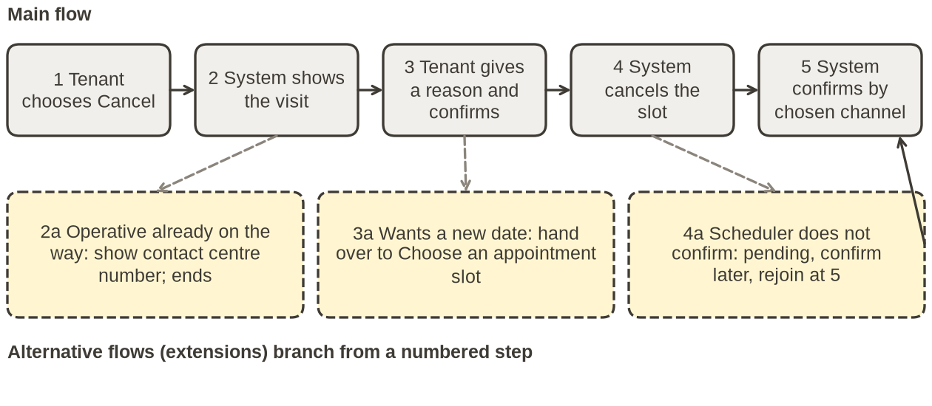
Figure 1: alternative flows (extensions) branch from a numbered step and either end the use case, hand over to another use case or rejoin the main flow.

2. The six requests and the policy extract (Activities 1 and 2)
Six requests from the synthetic data in Kestrel Moor Homes - Repair Requests.xlsx (sheet Requests). Dates are day/month/year, 24-hour clock. contacts_about_issue counts the tenant's contacts about this same problem, including this one; vulnerability_note is blank when none is recorded.
request_​id, reported_​at, channel | category | tenant_​description | vulnerability_​note | priority_​assigned | contacts_​about_​issue
KMR-26-0019  06/09/2026 10:18  Web form | Gas smell | Gas smell near the meter cupboard | (blank) | Routine | 3
KMR-26-0039  11/09/2026 15:25  Web form | Electrical | Burning smell from the fuse box, lights flickering | (blank) | Routine | 1
KMR-26-0043  13/09/2026 08:47  Email | Damp and mould | Black mould in the baby's bedroom again | (blank) | Urgent | 3
KMR-26-0050  15/09/2026 22:12  Web form | Damp and mould | Black mould in the baby's bedroom again | (blank) | Urgent | 1
KMR-26-0115  03/10/2026 07:00  Web form | Heating or hot water | No heating at all since yesterday | (blank) | Emergency | 1
KMR-26-0046  14/09/2026 15:18  Phone | Heating or hot water | No heating at all since yesterday | (blank) | Urgent | 1

Policy extract: Case Brief Part 4, Repair Priority Policy
• Emergency (attend and make safe within 24 hours): any smell of gas; exposed wiring, sparking or a burning smell from electrics; water coming through a ceiling or light fitting, or a leak that cannot be contained; no heating at all between 1 October and 30 April inclusive, or at any time of year if the household has a recorded vulnerability; an external door that cannot be locked.
• Urgent (attend within 5 working days) includes no heating at all outside the emergency dates for a household with no recorded vulnerability, and every report of damp or mould.
• Emergencies by phone: emergencies must be reported by phone so that an adviser can give safety advice; the online form must not accept them. A tenant who smells gas must first call the National Gas Emergency Service on 0800 111 999. Tenants who cannot use a voice call make the same calls through Relay UK by dialling 18001 before the number (the Relay UK app adds it for them). Kestrel Moor's emergency repairs line accepts relay calls 24 hours a day.
• Damp and mould: every report gets an investigation visit within 10 working days. If the same home has reported damp or mould before, the new report is linked to the earlier ones and the case goes to the Damp and Mould Lead.
• Triage: every request, from any channel, is given a priority within 24 hours of being received.

3. User stories and acceptance criteria (Activity 2)

INVEST checklist (Bill Wake, 2003)
Letter | Quality | Ask yourself
I | Independent | Can it be built and released without waiting for another story?
N | Negotiable | Does it leave the how open for the team to discuss?
V | Valuable | Would a tenant or Kestrel Moor notice the benefit?
E | Estimable | Could the team give it a rough size today?
S | Small | Can it be finished inside one sprint?
T | Testable | Could a tester write a test from it without asking you?

Writing a criterion
• Given the starting state: the data already true (who, which home, what date, what history).
• When one action or event: the tenant does something, or a time passes.
• Then an observable result a tester can see on screen, in a message or in the record.
• Give each criterion an ID (AC1, AC2) so a test can point to it. Avoid words a tester cannot check: quickly, promptly, clearly, appropriate, as expected.

Boundaries
For any rule with a limit (a date, hours, a count), write a boundary pair: one criterion on the limit and one just outside it. The pair is required. A third criterion just inside the limit is optional when the rule is a range. Off-by-one mistakes live at the boundary: "before" or "on or before".
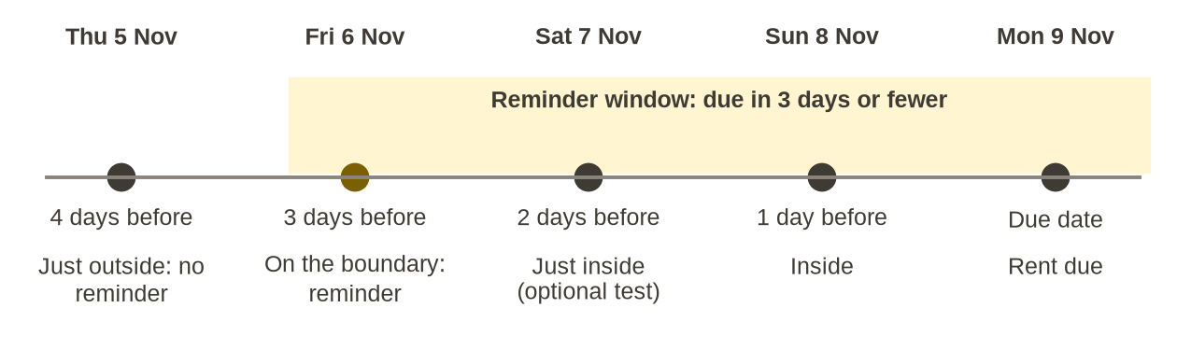
Figure 2: the boundary for the rent reminder rule in the worked example below.

Safety rules
When the policy says something must never happen, write a criterion that lets a tester prove it cannot happen, not just that it is unlikely. Check that everyone the rule protects can act on what the Then shows.

Worked example: a rent reminder (a different system from the portal)
Story: As a tenant who pays rent by card, I want a reminder when rent is due in 3 days or fewer, so that the money is ready on the day.
• AC1 (on the boundary): Given rent due on Monday 9 November is unpaid and no reminder has gone, When the daily job runs on Friday 6 November, Then one reminder goes by the tenant's chosen channel.
• AC2 (just outside): Given the same, When the job runs on Thursday 5 November, Then no reminder is sent.
• AC3 (negative): Given rent due on Monday 9 November is already paid, When the job runs on Friday 6 November, Then no reminder is sent.

4. From criteria to test scenarios (Activity 3)
• Positive: the rule does what it should when its condition is true.
• Negative: change one condition so the rule should not apply, and check that nothing happens.
• Boundary: one test on the limit and one just outside it.
• Safety: prove that the dangerous outcome cannot happen.
Each test records a Test ID, the Criterion it checks, the exact Input or data and the Expected result a tester can see, as in workbook Part 3.
Test ID | Criterion it checks | Input or data | Expected result
T1 | AC1 (on the boundary) | Unpaid; due Mon 9 Nov; job runs Fri 6 Nov | One reminder by the chosen channel
T2 | AC2 (just outside) | Unpaid; due Mon 9 Nov; job runs Thu 5 Nov | No reminder
T3 | AC3 (negative) | Paid; due Mon 9 Nov; job runs Fri 6 Nov | No reminder
T4 | None covers it | Unpaid, no reminder yet; job runs Sat 7 Nov | Unknown: ask the product owner and add a criterion

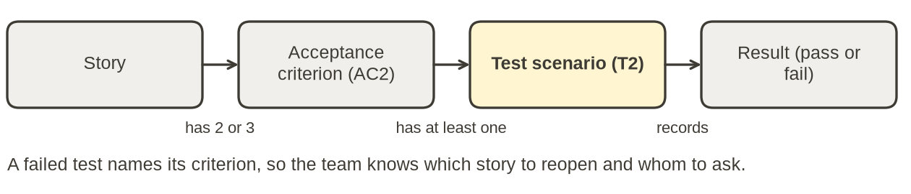
Figure 3: traceability from story to test result.

When a criterion cannot be tested (extension)
• The Then uses a word nobody can measure, or holds two results.
• The Given has no data: which household, which date, which history?
• It describes the code, not behaviour a user or tester can observe.
Record the criterion ID, the reason and who should fix it in the could-not-test table in your workbook, and tell the author. Do not fix it quietly: the author rewrites it, and the product owner agrees any change to what the policy requires.

